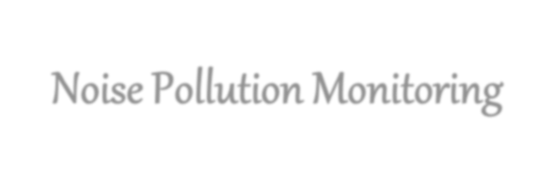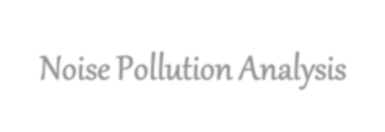

* Use historical noise data and machine learning models to predict future noise levels.
* This can help in proactive noise control measures, such as scheduling noisy activities during quieter times or alerting residents to noise spikes.



* Apply data analytics to create "soundscape" designs for urban planning.
* This involves not only reducing noise but also enhancing pleasant sounds in urban areas, making them more livable.



* Implement artificial intelligence (AI) and sound recognition technologies to automatically identify and classify noise sources in real-time.
* This can provide immediate insights into what is causing noise issues.



* Develop smart noise sensors equipped with data analytics capabilities that can be deployed across a city.
* These sensors can continuously collect data and send alerts when noise levels exceed acceptable limits.



* Build online platforms or mobile apps that allow residents to report noise disturbances.
* Combine this crowdsourced data with sensor data for a comprehensive understanding of noise issues and their spatial distribution.



Create dynamic noise maps that update in real-time or on a frequent basis, providing policymakers and residents with up-to-date information about noise levels and sources.

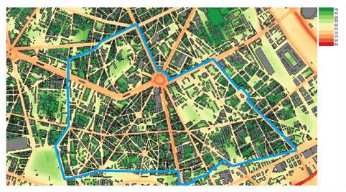

* Utilize AI algorithms to design noise barriers that are not only effective but also aesthetically pleasing.

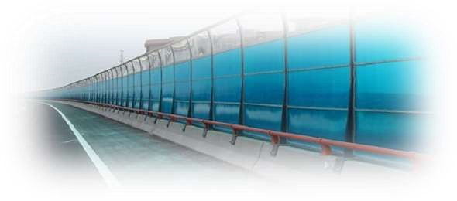

* Data analytics can help optimize barrier placement and design based on noise patterns.



➢Implement data-driven health impact assessments to quantify the effects of noise pollution on public health.

➢This can inform policy decisions and prioritize noise mitigation efforts.



* Integrate noise data analytics into broader smart city initiatives.
* This can enable data sharing across various city systems, leading to more efficient noise management in tandem with other urban services.



❖ Utilize data analytics to identify trends in noise complaints and target public awareness campaigns to specific areas or demographics that are most affected by noise pollution.



✓Incorporate noise data analytics into urban planning processes, ensuring that new developments and infrastructure projects are designed with noise mitigation in mind from the start.



➢Develop automated systems that monitor and report on compliance with noise regulations, allowing authorities to take swift action against violators.



✓ Innovative approaches like these can transform noise pollution management from a reactive process to a proactive and data-driven one. By leveraging the power of data analytics and technology, cities and communities can create quieter, healthier, and more pleasant environments for residents and businesses alike.

Design principle:

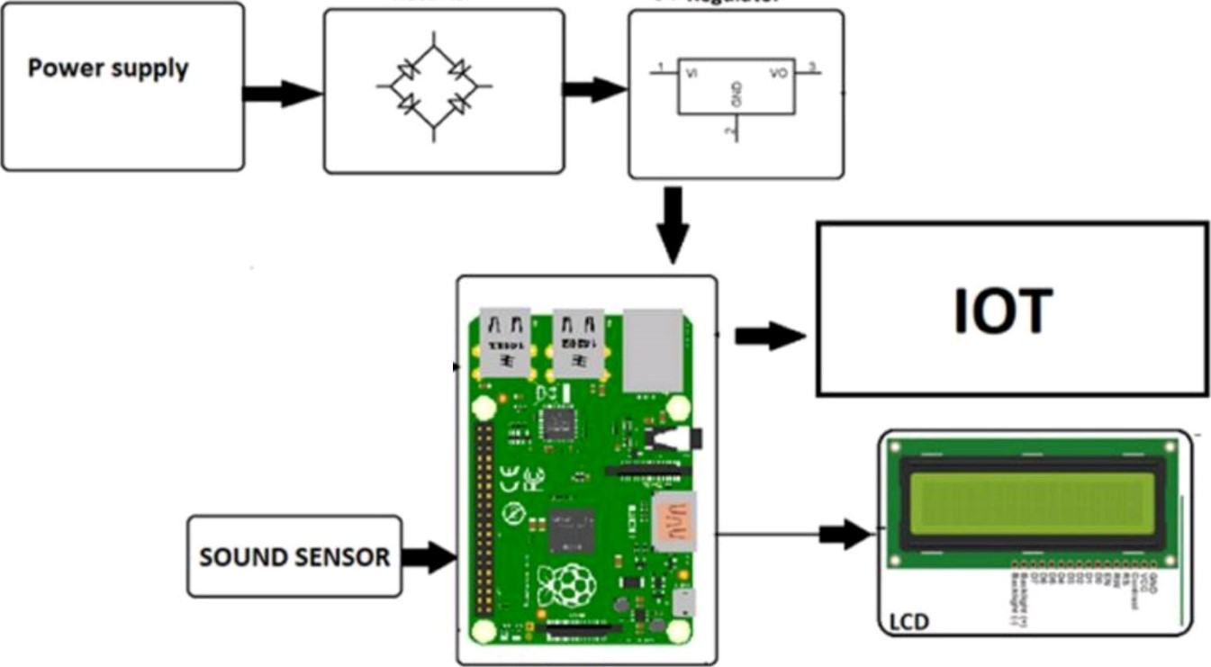

Rectifier

SV

Regulator

Raspberry

Pi

